**Monitoring AWS EKS using Prometheus and Grafana**

**Prerequisites**

* an AWS account;
* [identity and access management (IAM) credentials and programmatic access;](https://aws.amazon.com/iam/?gclid=CjwKCAiAopuvBhBCEiwAm8jaMRr63J8flYOSdCcw52cGaELcZ4P16MNpwSnoUhTMHEh20VyNhIWm4RoC8G4QAvD_BwE&trk=858d3377-dc99-4b71-b7d9-dfbd53b3fb6c&sc_channel=ps&ef_id=CjwKCAiAopuvBhBCEiwAm8jaMRr63J8flYOSdCcw52cGaELcZ4P16MNpwSnoUhTMHEh20VyNhIWm4RoC8G4QAvD_BwE%3AG%3As&s_kwcid=AL%214422%213%21651612429260%21e%21%21g%21%21amazon+iam%2119836375022%21146902912253)
* [AWS credentials that are set up locally with aws configure;](https://docs.aws.amazon.com/cli/latest/userguide/cli-chap-configure.html)
* [AWS Ubuntu 22.04 LTS Instance.](https://www.devopshint.com/create-ec2-instance-in-aws-and-ssh-using-mobaxterm/)(type:t2micro)
* Install some command-line tools .i.e. — eksctl, kubectl, and Helm Chart.

**Step#1:Install and Setup kubectl on Ubuntu Server**

Installing and setting up kubectl configures the command-line interface essential for managing Kubernetes clusters

sudo curl --silent --location -o /usr/local/bin/kubectl https://s3.us-west-2.amazonaws.com/amazon-eks/1.22.6/2022-03-09/bin/linux/amd64/kubectl

sudo chmod +x /usr/local/bin/kubectl

kubectl version --short --client

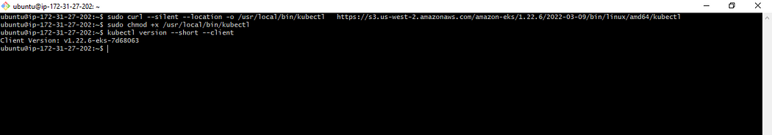

**Step#2:Install and Setup eksctl on Ubuntu Server**

Installing and setting up eksctl simplifies the process of creating and managing Amazon EKS clusters with its command-line utility.

curl --silent --location   
"https://github.com/weaveworks/eksctl/releases/latest/download/eksctl_$  
(uname -s)_amd64.tar.gz" | tar xz -C /tmp

Move the extracted binary to /usr/local/bin

sudo mv /tmp/eksctl /usr/local/bin

Check whether the installation has been successfully done using

eksctl version

**Step#3:Install Helm Chart on Ubuntu Server**

Installing Helm Charts involves deploying pre-configured packages onto Kubernetes clusters.

curl -fsSL -o get_helm.sh https://raw.githubusercontent.com/helm/helm/main/  
scripts/get-helm-3

chmod 700 get_helm.sh

./get_helm.sh  
DESIRED_VERSION=v3.8.2 bash get_helm.sh  
curl -L https://git.io/get_helm.sh | bash -s -- --version v3.8.2

The following script installs Helm, a vital tool for Kubernetes application management. Helm serves as a package manager within the open-source Kubernetes platform, simplifying application installation, updates, and removal.

You can verify the helm installation using

helm version

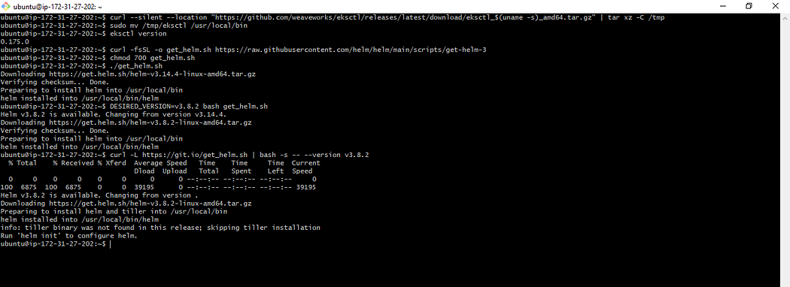

Now, here we are done with the installation of **kubectl**, **eksctl** and **Helm**

**Step#4:Creating an Amazon EKS Cluster using eksctl**

Creating an Amazon EKS Cluster using eksctl streamlines the process of setting up and managing Kubernetes clusters on AWS. It provides a simplified command-line interface for creating EKS clusters with predefined configurations, ensuring efficient cluster deployment.

eksctl create cluster --name=eks-cluster --region=us-east-1  
 --version=1.29 --nodegroup-name=my-nodes --node-type=t3.medium   
--managed --nodes=2 --nodes-min=2 --nodes-max=3

Kindly note that it would take 15–20 minutes for this installation to complete. Once it is done, you can go to your AWS Console and look for the eksctl clusters

We can verify the cluster by logging into the AWS Console

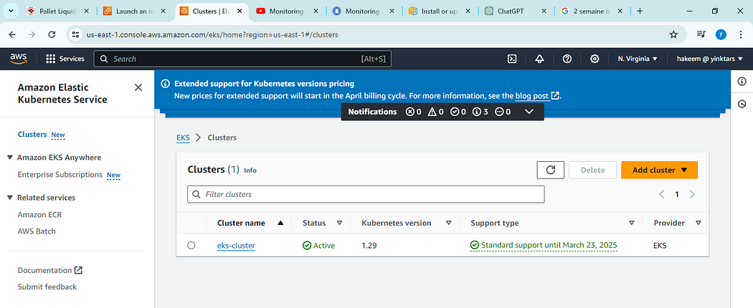

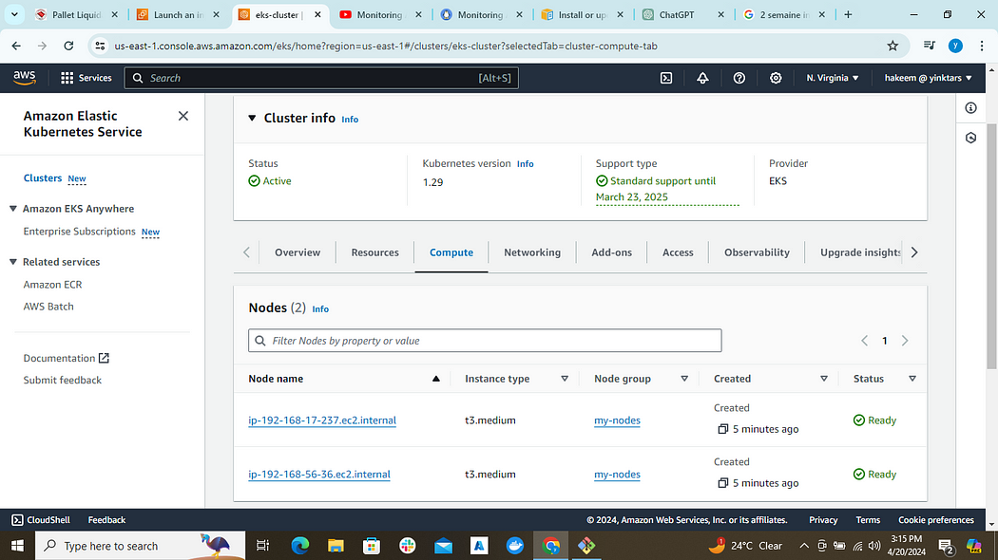

eksctl get cluster --name eks-cluster --region us-east-1

This should confirm that EKS cluster is up and running.

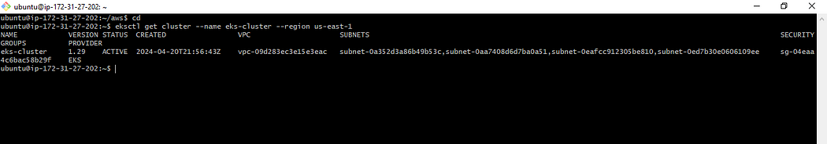

Update Kube config by entering below command:

aws eks update-kubeconfig --name eks-cluster --region us-east-1

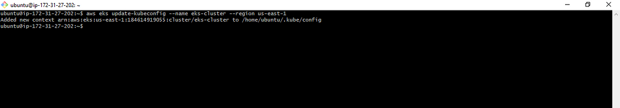

Connect to EKS cluster using kubectl commands

To view the list of worker nodes as part of EKS cluster.

kubectl get nodes

kubectl get ns

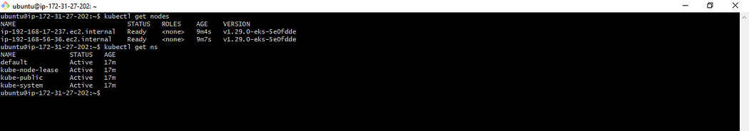

**Step#5:Add Helm Stable Charts for Your Local Client**

We need to add the Helm Stable Charts for your local client. Execute the below command:

helm repo add stable https://charts.helm.sh/stable

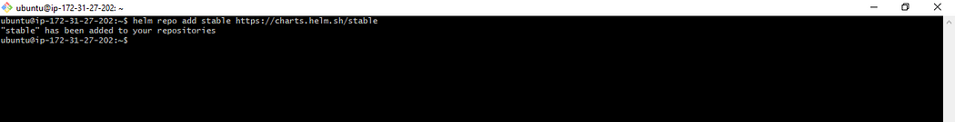

**Step#6:Add Prometheus Helm Repository**

helm repo add prometheus-community https://prometheus-community.github.io/helm-charts

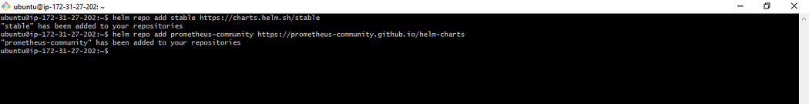

**Step#7:Create Prometheus Namespace**

kubectl create namespace prometheus

kubectl get ns

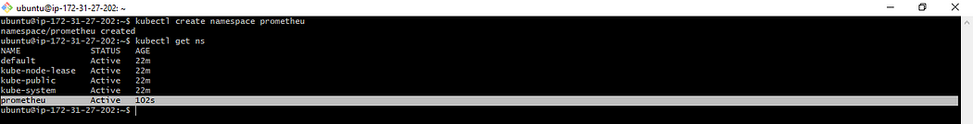

**Step#8:Install Prometheus using Helm**

helm install stable prometheus-community/kube-prometheus-stack -n prometheus

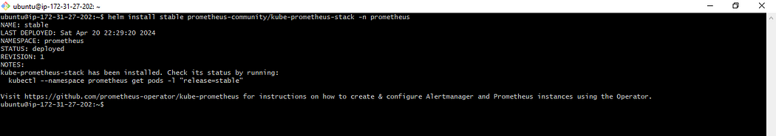

above command is used to install kube-Prometheus-stack. The helm repo kube-stack-Prometheus comes with a Grafana deployment embedded ( as the default one ).

To verify if Prometheus has been successfully installed using Helm on the EC2 instance, you can execute the following command:

kubectl get pods -n prometheus

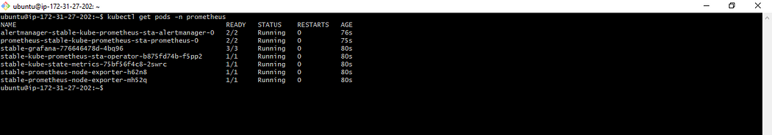

to check the services file (svc) of the Prometheus

kubectl get svc -n prometheus

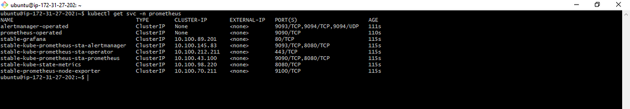

The inclusion of Grafana alongside Prometheus in the stable version confirms the successful installation of Prometheus. Since Grafana is bundled with Prometheus, there’s no need for a separate installation.

**Step#9:Expose Prometheus and Grafana to the external world**

Let’s expose Prometheus and Grafana to the external world  
there are 2 ways to expose

1. through Node Port
2. through LoadBalancer

let’s go with the LoadBalancer  
to attach the load balancer we need to change from ClusterIP to LoadBalancer  
command to get the svc file

kubectl edit svc stable-kube-prometheus-sta-prometheus -n prometheus

change it from Cluster IP to LoadBalancer after changing make sure you save the file

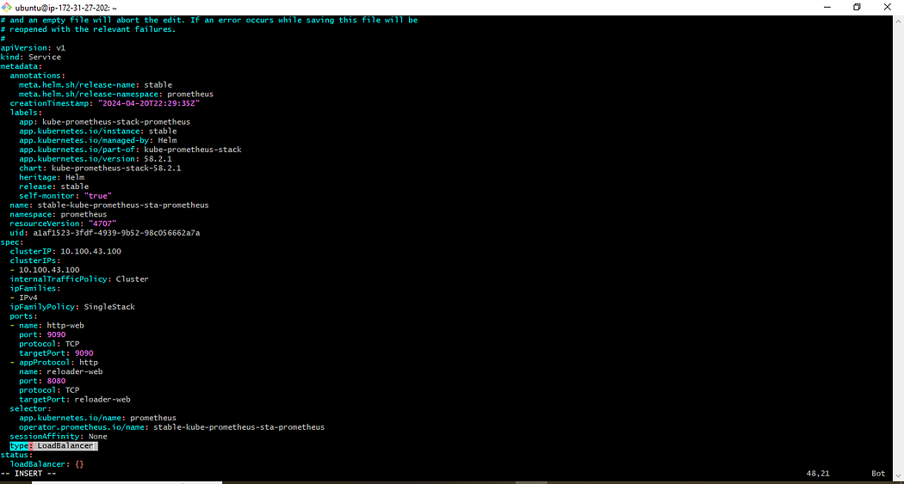

kubectl get svc -n prometheus

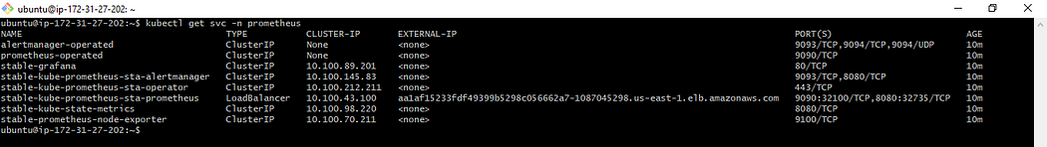

As evidenced, a load balancer has been provisioned for Prometheus, allowing access via the link provided on port 9090.

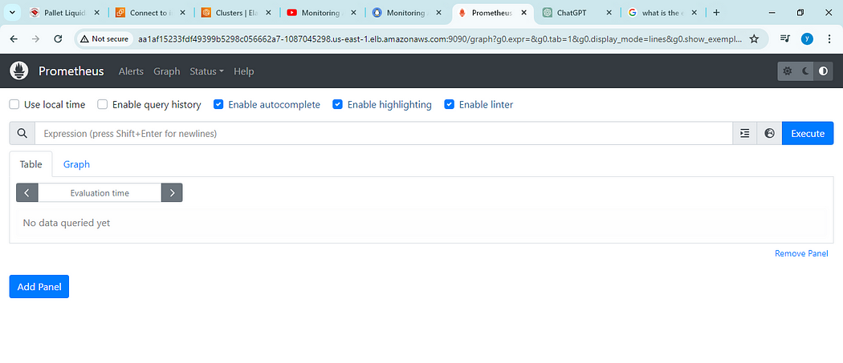

Now,let’s change the SVC file of the Grafana and expose it to the outer world

command to edit the SVC file of grafana

kubectl edit svc stable-grafana -n prometheus

change it from Cluster IP to LoadBalancer after changing make sure you save the file

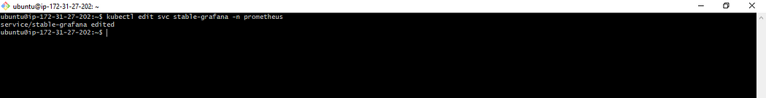

kubectl get svc -n prometheus

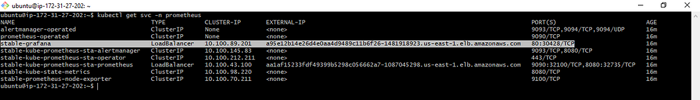

use the link of the LoadBalancer and access from the Browser

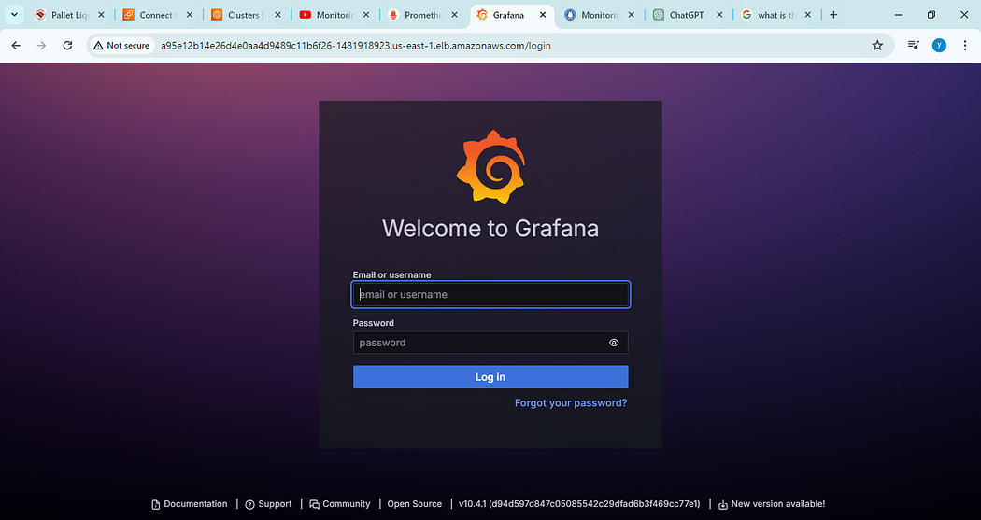

kubectl get secret --namespace prometheus stable-grafana -o jsonpath="{.data.admin-password}" | base64 --decode ; echo

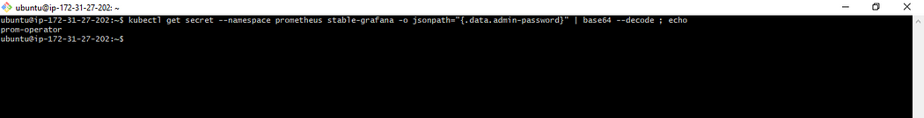

use the above command to get the password  
the user name is admin

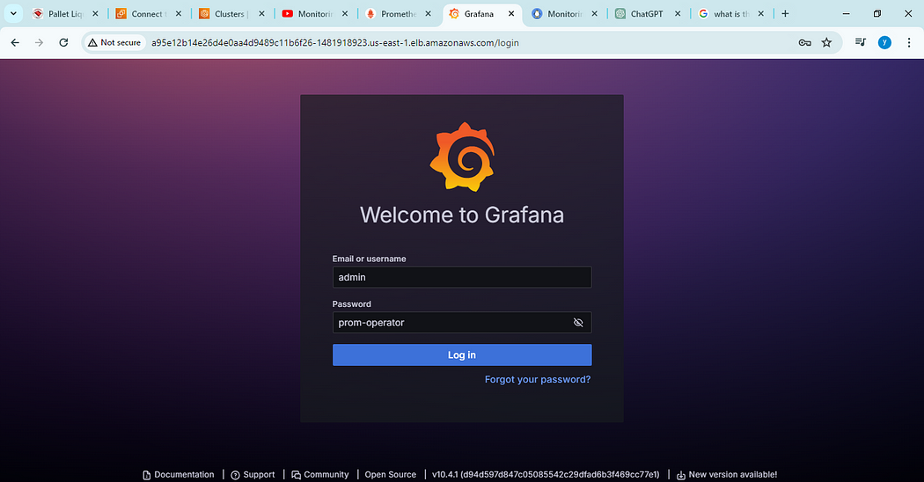

Now, view the Dashboard in Grafana

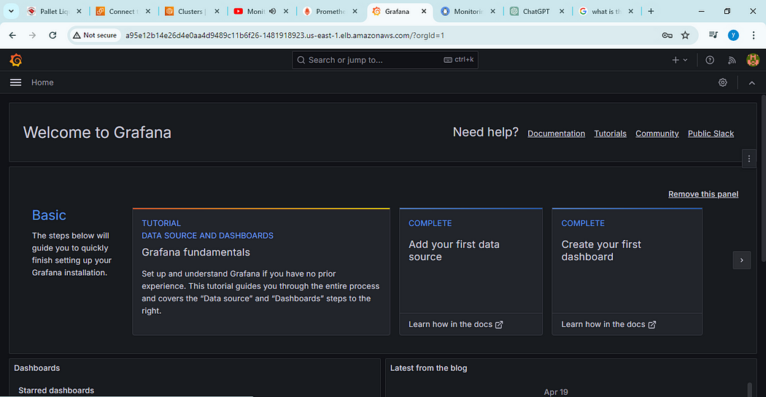

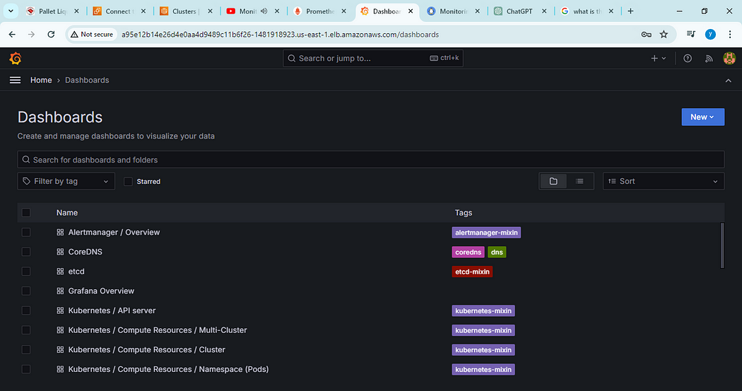

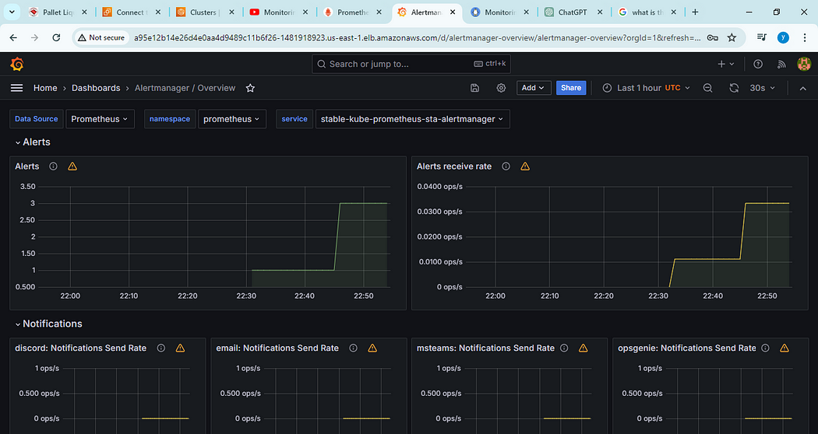

the Entire data of the cluster  
where we can able to see the entire data of the EKS cluster

**Conclusion:**

In conclusion, setting up Prometheus and Grafana dashboards for monitoring AWS EKS offers a robust solution for observing and managing your Kubernetes clusters. With Prometheus collecting metrics and Grafana providing visualization capabilities, users gain insights into cluster health, resource utilization, and performance metrics.